Nischal Shrestha
Coventry University Student ID Number: 17103446
B.Sc. (Hons.) Computing, Softwarica College of IT and E-commerce, Coventry University
ST4005CEM Database System
Giriraj Rawat

- Find students aged between 18 and 21

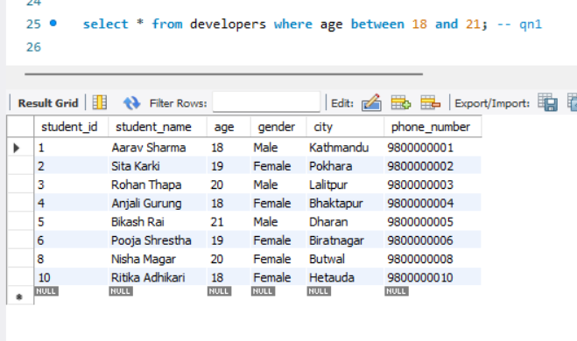

- Find students whose age is not between 20 and 22
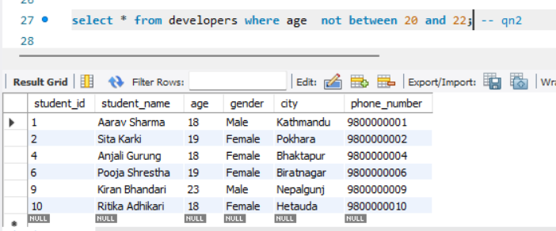

- Find students with student_id between 2 and 4
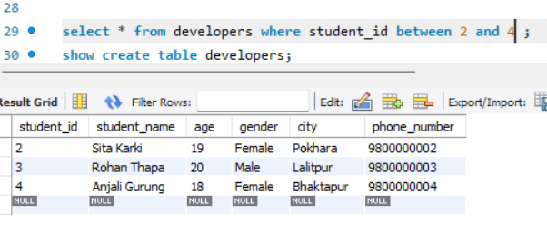

- Find students whose phone number starts between '980' and '985'
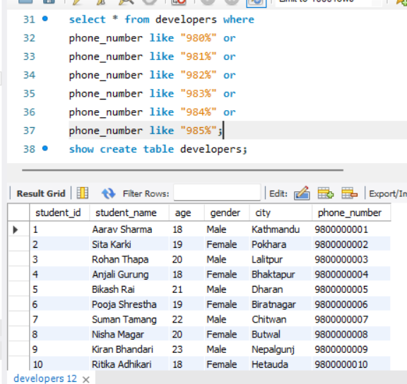

- Find students from 'ktm', 'dharan', or 'butwal'
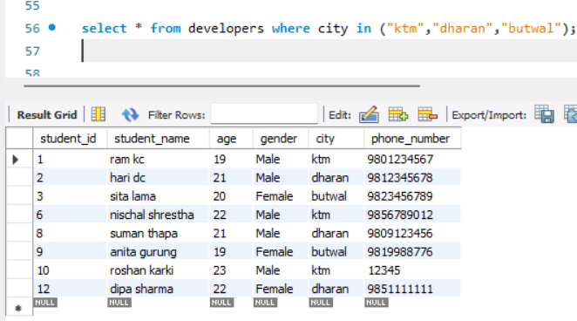

- Find students not from 'dang' or 'chitwan'
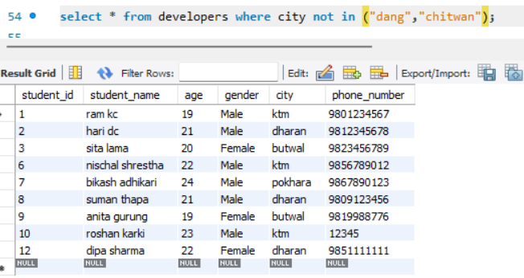

- Find students with age 19, 21, or 23
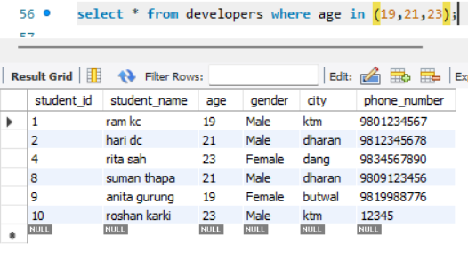

- Find students whose names are not 'ram kc' or 'hari dc'
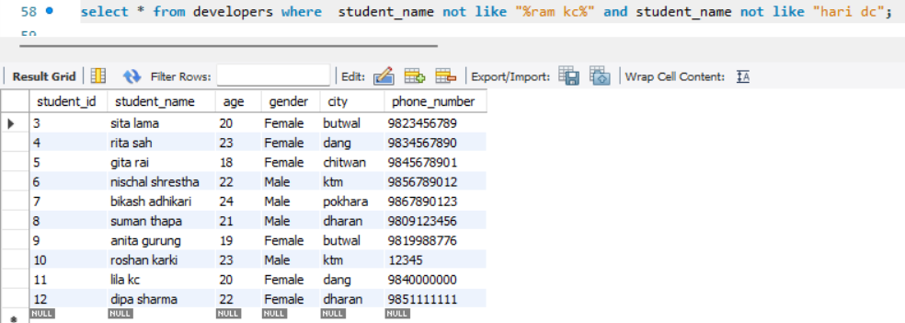

- Find students with gender 'm' or 'f' (using IN)
- Male
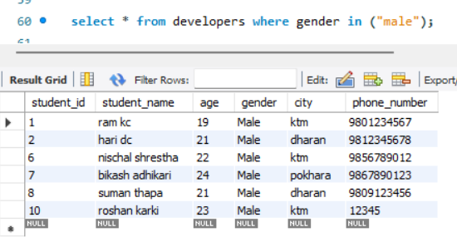

- Female
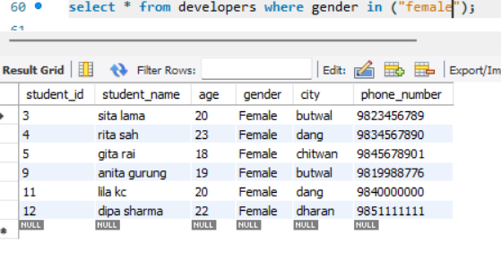

- Categorize students as 'Teen' (age <20), 'Young Adult' (20-22), or 'Adult' (23+)
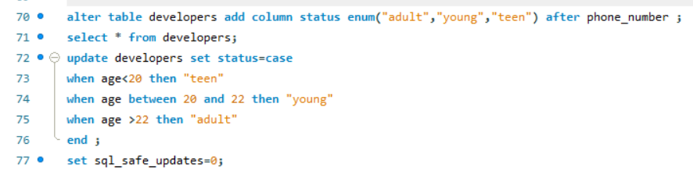
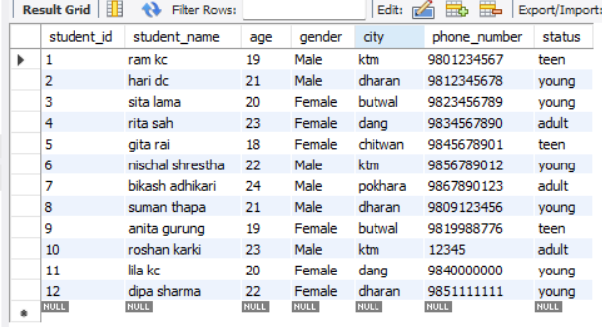

- Label students from 'ktm' as 'Capital' and others as 'Other City'.
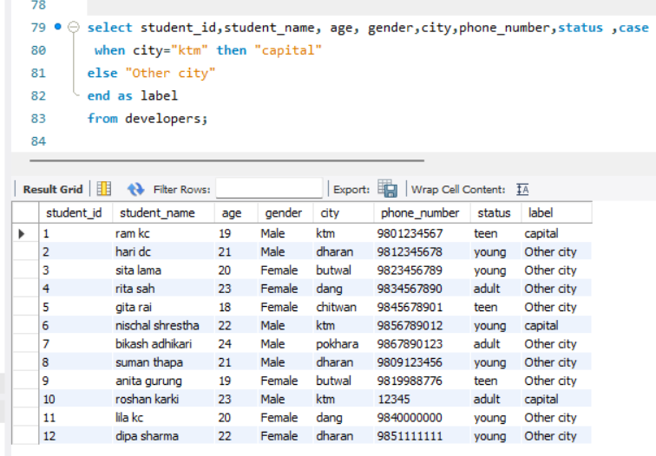

- Create a column showing 'Valid' if phone has 10 digits, else 'Invalid'

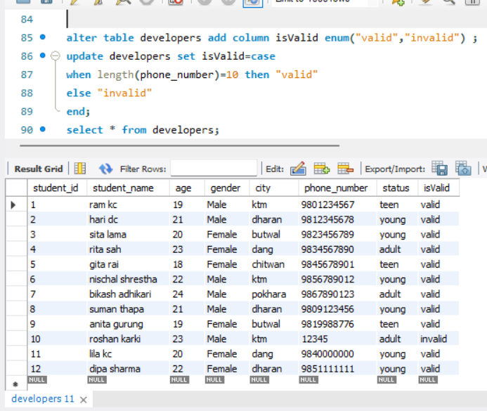

- Classify students as 'Male', 'Female', or 'Other' based on gender
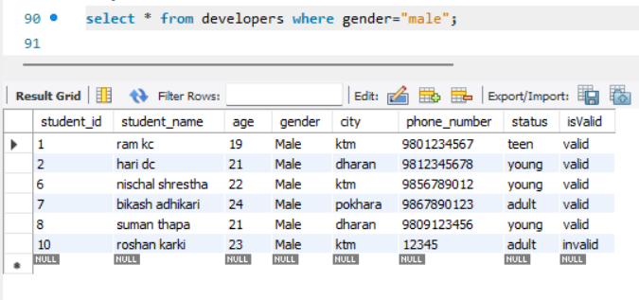

- Mark students as 'Junior' (age <21) or 'Senior' (age ≥21)
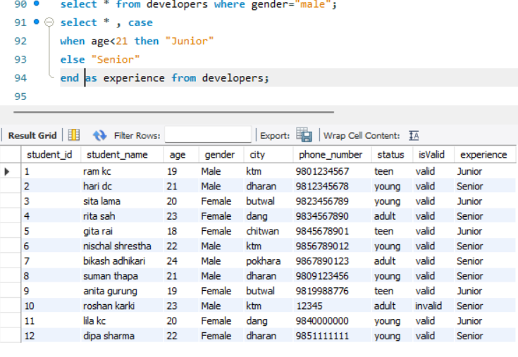

- Find female students from 'ktm' or 'butwal'
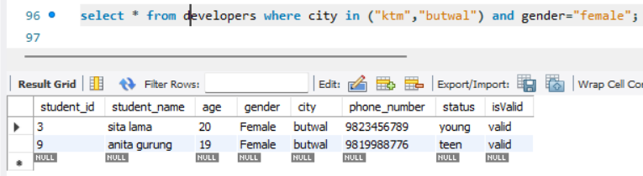

- Find male students aged 20 or from 'dharan'

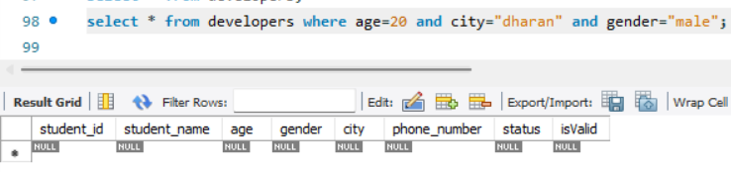

- Find students aged 19-21 who are not from 'dang'

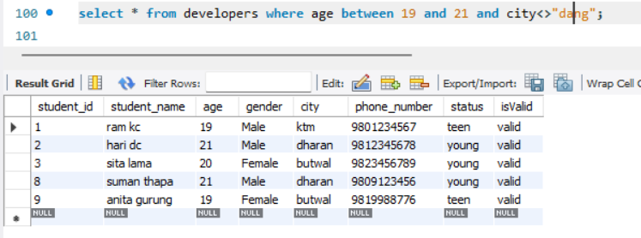

- Find students whose name starts with 'r' and age >20.
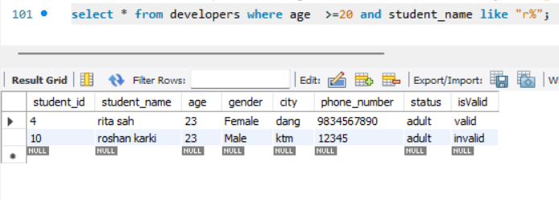

- Find students from 'ktm' or with phone starting with '9809'
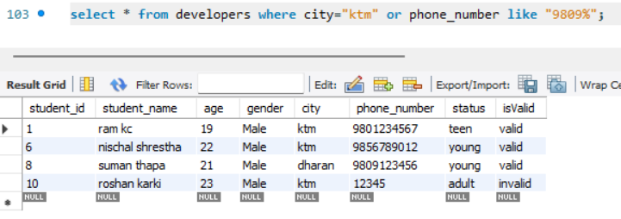

- Find students with 'sh' in their name
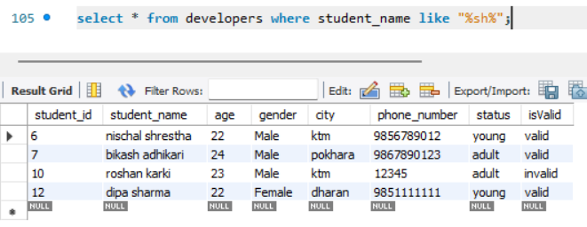

- Find students whose name starts with 'r'
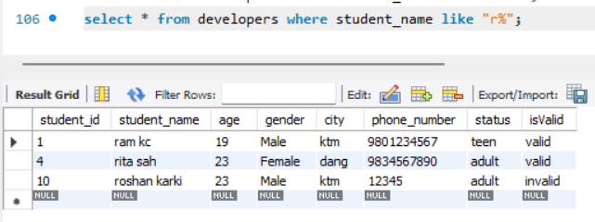

- Find students whose name ends with 'a'
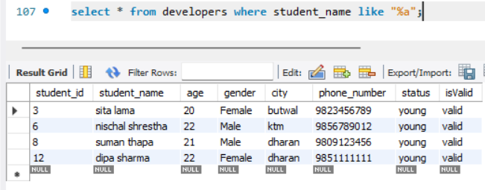

- Find students with 'a' as the second letter in their name
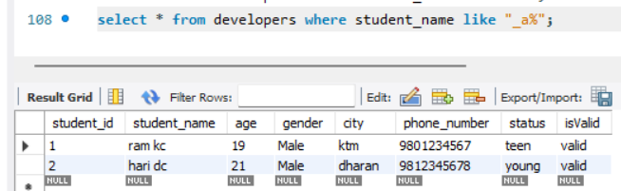

- Find students whose name doesn't contain 'a'
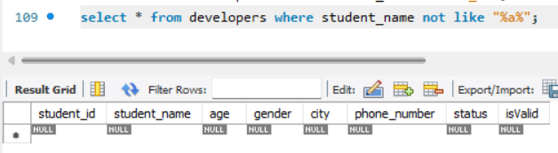

- Find students with exactly 4 letters in first name (like 'ram kc')

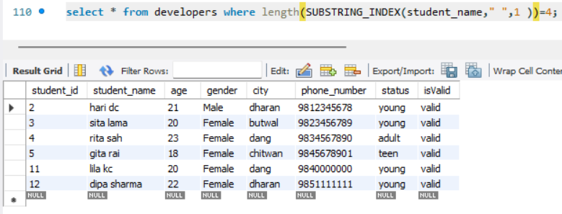

- Find students with two-part names (containing space)

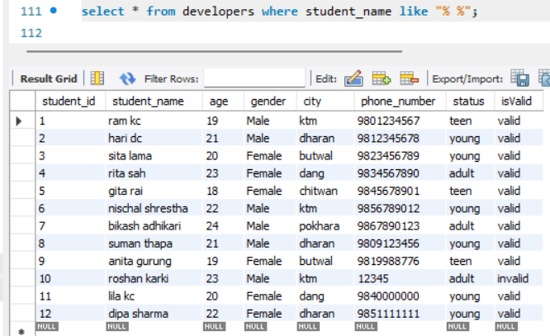

- Find students whose city name starts with 'd' and has 5 letters
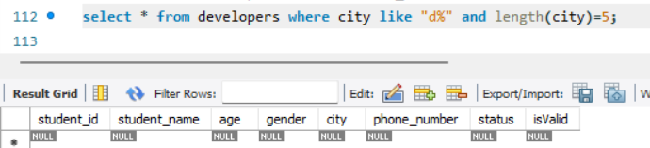

- Find students whose name has 'i' as the third character
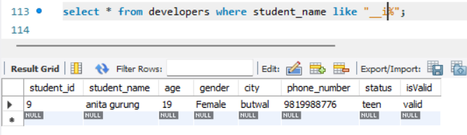

- Find students whose name doesn't start with 'r' or 's'
